Observations to improve marketing strategies
Facebook:
Link posts in some cases may reach more fans than photos, even if they don’t click on the links.
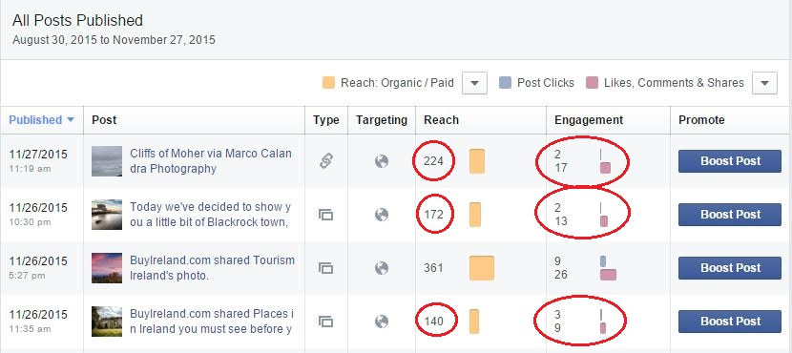
As the picture above suggest it: More clicks on posts don’t always mean more reach. The two photos posts created more engagement clicks (not engagement likes, comments and shares) than the link one and were less popular.
This may means that wanting a user to click on a post will not necessary retain his attention. The post needs to be above all else a quality one more than a post/link/text or video post. This may means that the type of post could be less important than the content of it.

